Topic:TryHackMe:SOC_Role_in_Blue_Team

Lab Overview
Platform: TryHackMe
Room:Cyber_Kill_Chain
Status: Completed

1. Introduction
In this section, I learned about the Blue Team and how a SOC L1 Analyst fits into a company's security structure.
The section focuses on understanding the role of the Blue Team, where the SOC is placed within an organization's structure, and how a SOC L1 analyst can progress through their cybersecurity career.

Learning Objectives
The main objectives of this room are:
- Understand the concept and purpose of the Blue Team
- Understand the place of the SOC within a company structure
- Learn about the career path of a SOC L1 Analyst
The room also mentions Junior Security Analyst Intro and SOC Roles and Processes as prerequisites.

The question asked:
“Let's find out!”
My answer was: Completed
Why: I read the introduction and understood the learning objectives and prerequisites of the room.

2. Security Hierarchy
In this section, I learned that cybersecurity priorities differ depending on the type of company. For example, a law firm may focus on protecting legal documents, while a factory may prioritize the availability of production lines, and a hospital may focus on patient safety.
I learned that in larger organizations, a CISO (Chief Information Security Officer) usually oversees the security function and helps create security departments based on the company's needs.

Security Departments
The room introduced three main security teams:
- Red Team — offensive security experts, penetration testers, and ethical hackers who look for security weaknesses.
- GRC Team — specialists who manage security policies and ensure compliance with regulations.
- Blue Team — defensive security professionals such as SOC analysts, security engineers, and incident responders.

Questions and Answers
1. Which senior role typically makes key cyber security decisions?
My answer was: CISO (Chief Information Security Officer)
Why: The room explains that the CISO understands the business's security needs and creates suitable security departments and strategies.

2. What is the common name for roles like SOC analysts and engineers?
My answer was: Blue Team
Why: SOC analysts and security engineers are described in the room as defensive security professionals who belong to the Blue Team.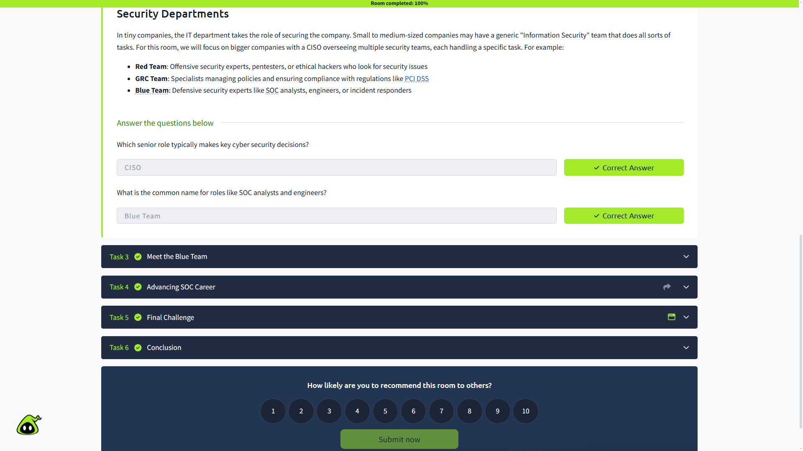

3. Meet the Blue Team
In this section, I learned that the Blue Team focuses on defensive security. Its main purpose is to continuously monitor for attacks and respond to them as quickly as possible.

Security Operations Center (SOC)
The SOC is the central hub for an organization's cybersecurity and acts as the first line of defense. A typical SOC can include:
- L1 Analysts — triage alerts and pass complex cases to L2.
- L2 Analysts — investigate more advanced attacks.
- Engineers — configure and maintain security tools such as EDR and SIEM.
- Manager — manages the SOC team.

Cyber Incident Response Team (CIRT)
I also learned about the Cyber Incident Response Team (CIRT), also known as CSIRT or CERT. CIRT handles serious or urgent cyber incidents when the SOC needs additional expertise or an incident becomes difficult to control.
CIRT can include specialists such as:
- Forensics experts
- Threat intelligence experts
- Threat hunters
- Malware analysts

Specialized Defensive Roles
Larger organizations may also have specialized Blue Team roles, such as:
- Digital Forensics Analyst
- Threat Intelligence Analyst
- AppSec Engineer
- AI Researcher

Questions and Answers
1. Does Blue Team focus on defensive or offensive security?
My answer was: Defensive security
Why: The room describes the Blue Team as the defensive side of cybersecurity, responsible for monitoring attacks and responding to them.

2. Which department handles active or urgent cyber incidents?
My answer was: CIRT (Cyber Incident Response Team)
Why: CIRT is called when SOC expertise is not enough or an incident becomes serious and requires urgent response.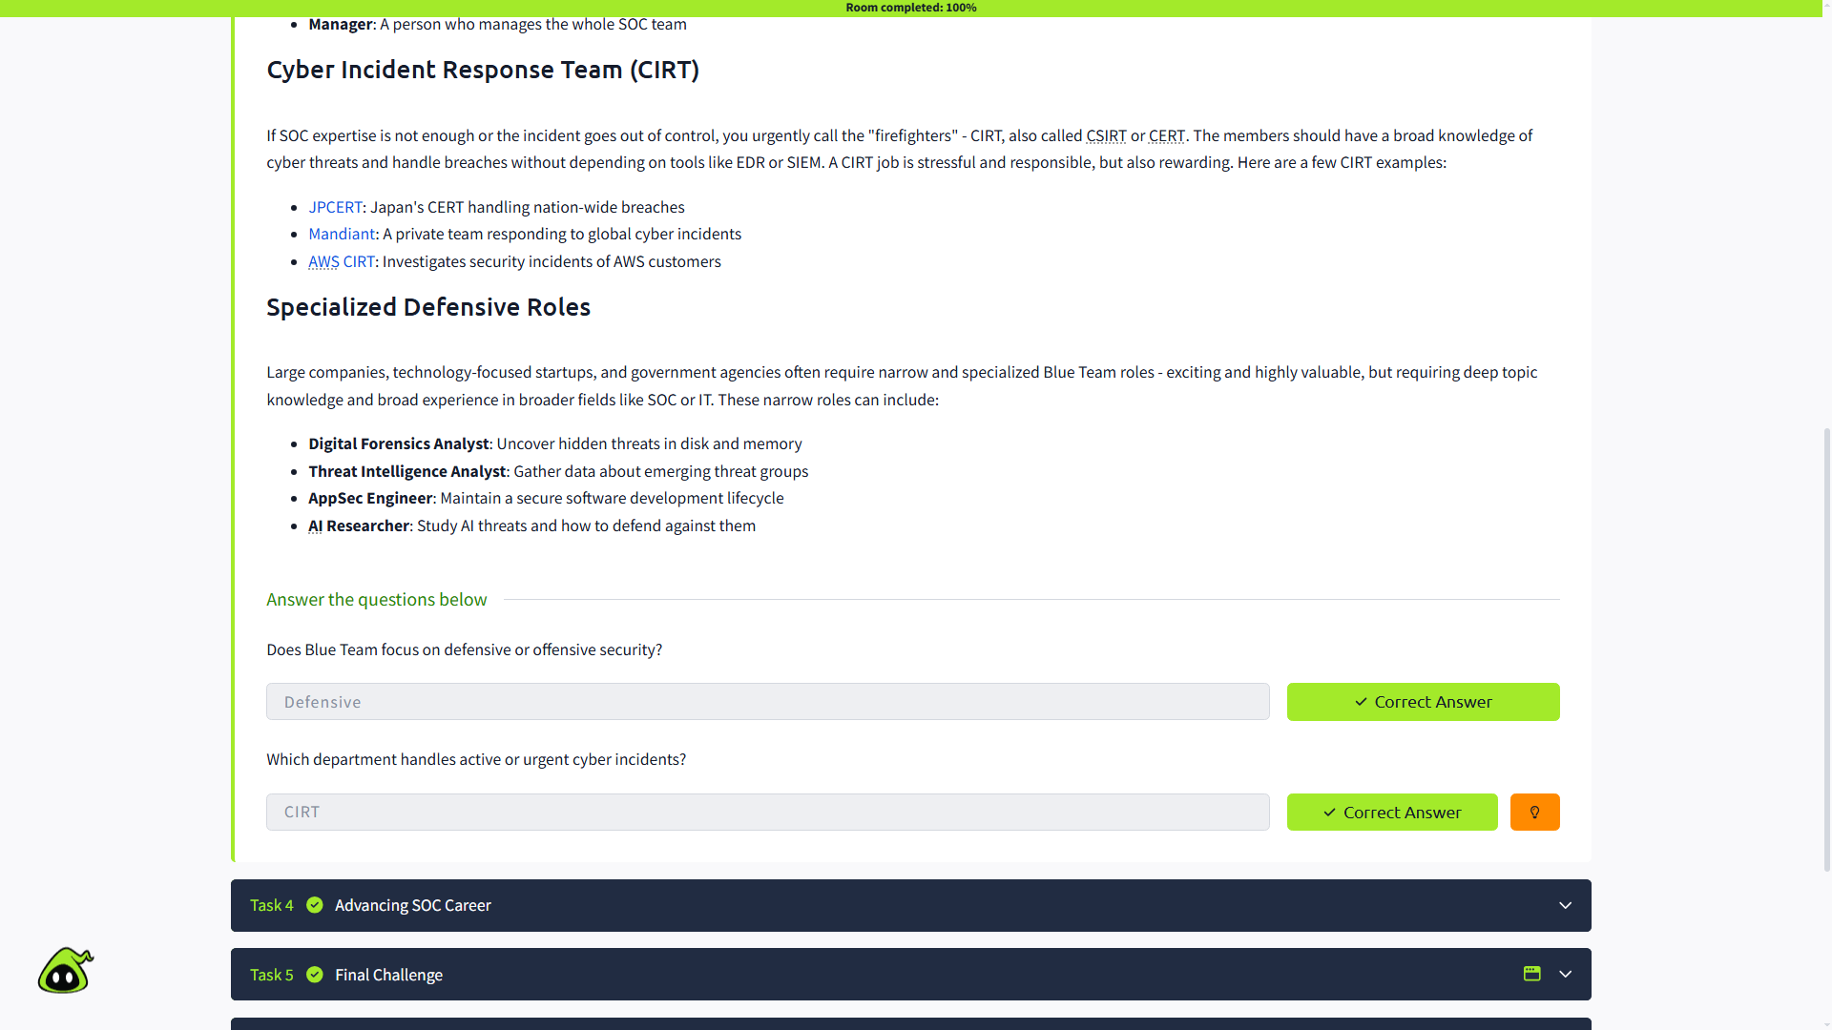

4. Advancing SOC Career
In this section, I learned about the SOC career path and how an entry-level SOC L1 Analyst can develop their career.
The room suggests starting by building core SOC skills and practicing them. It also recommends being proactive through CTFs, following cybersecurity news, preparing for interviews, and applying for SOC positions.

Internal SOC vs MSSP
I learned that an MSSP (Managed Security Services Provider) is a company that provides outsourced security services, commonly including SOC services, to other organizations.
An Internal SOC works directly for its own organization, while an MSSP provides security services to multiple customers.

Career Progression
After gaining experience as an L1 analyst, the natural next step is usually SOC L2 Analyst. However, an analyst can also move toward other areas such as security engineering, CIRT, management, or eventually a CISO role.
The room also gives four important tips:
- Learn from every alert
- Think like an attacker
- Verify everything
- Get involved in incidents

Questions and Answers
1. How would you call a cyber security company providing SOC services?
My answer was: MSSP (Managed Security Services Provider)
Why: An MSSP is a company that provides outsourced security services, most commonly SOC services, to its clients.

2. Which role naturally continues your SOC L1 analyst journey?
My answer was: SOC L2 Analyst
Why: The room identifies SOC L2 as the most natural next step after working as a SOC L1 Analyst and gaining real-world experience.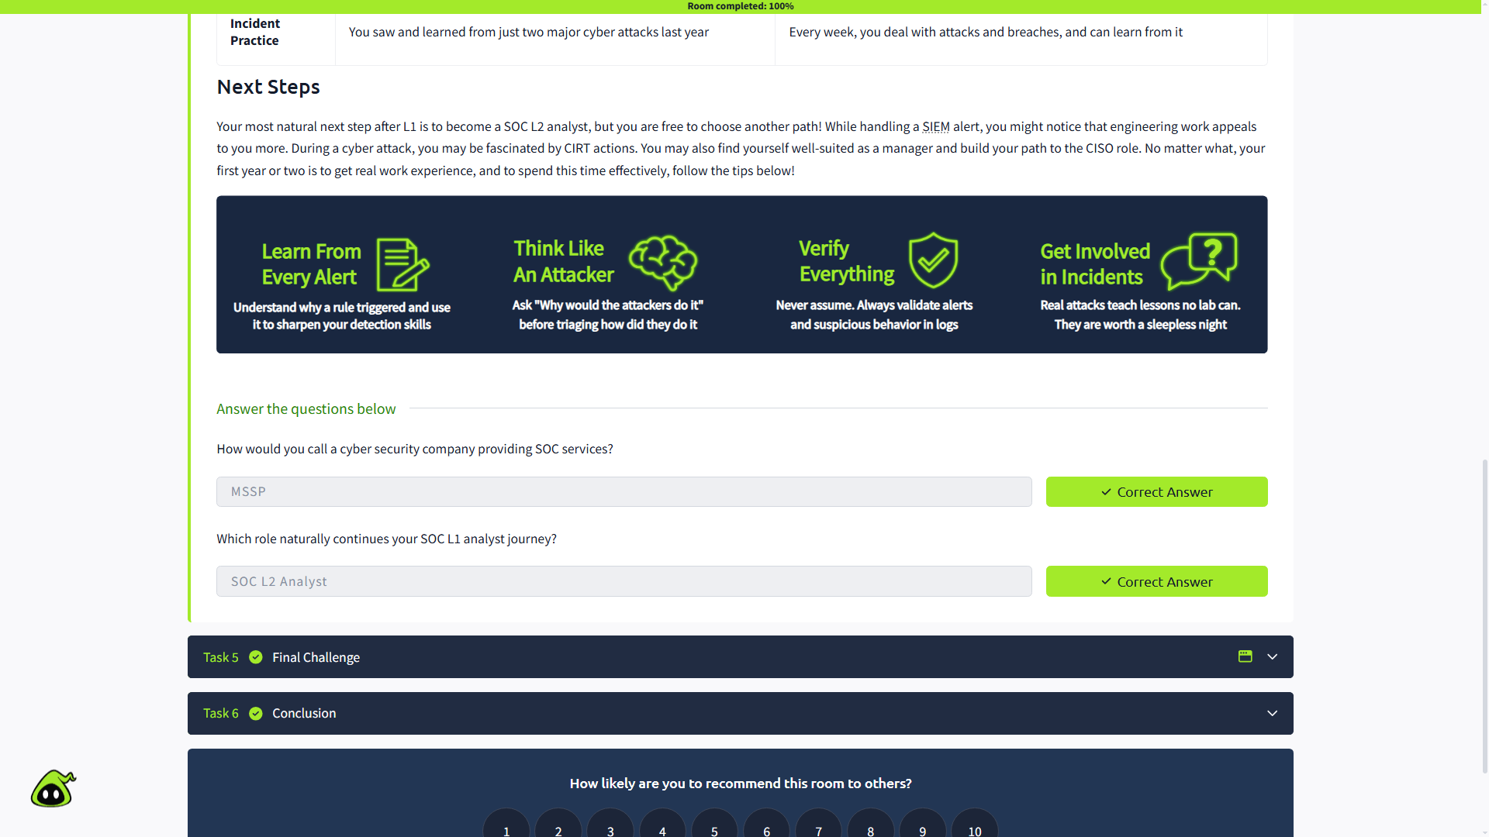

5. Final Challenge
In this section, I completed the Final Challenge by matching the appropriate security roles to the seven incidents in the TrySecureMe scenario.

The question asked:
“What flag did you claim after completing the final challenge?”
My answer was: [THM{trysecureme_is_secured!}]
Why: The flag is generated/displayed by the interactive challenge after all seven incidents are matched with the correct security roles
Correct Answer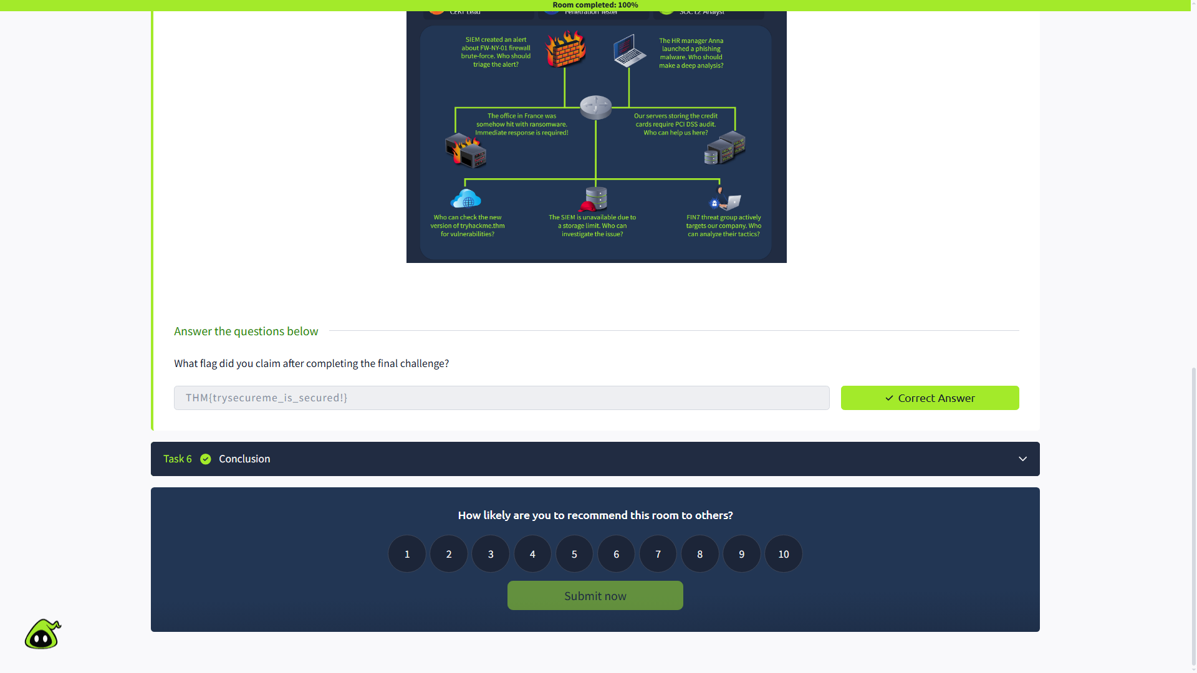

6. Conclusion
In this section, I completed the room and reviewed how the SOC team works, where the SOC fits within an organization's security structure, and the skills needed to begin a cybersecurity career.
The room also introduced the next topics in the learning path:
- Humans as Attack Vectors
- Systems as Attack Vectors

The question asked:
“Complete the room!”
My answer was: Completed ✅
Why: I completed all the tasks in the room and finished the SOC career and Blue Team learning path.

